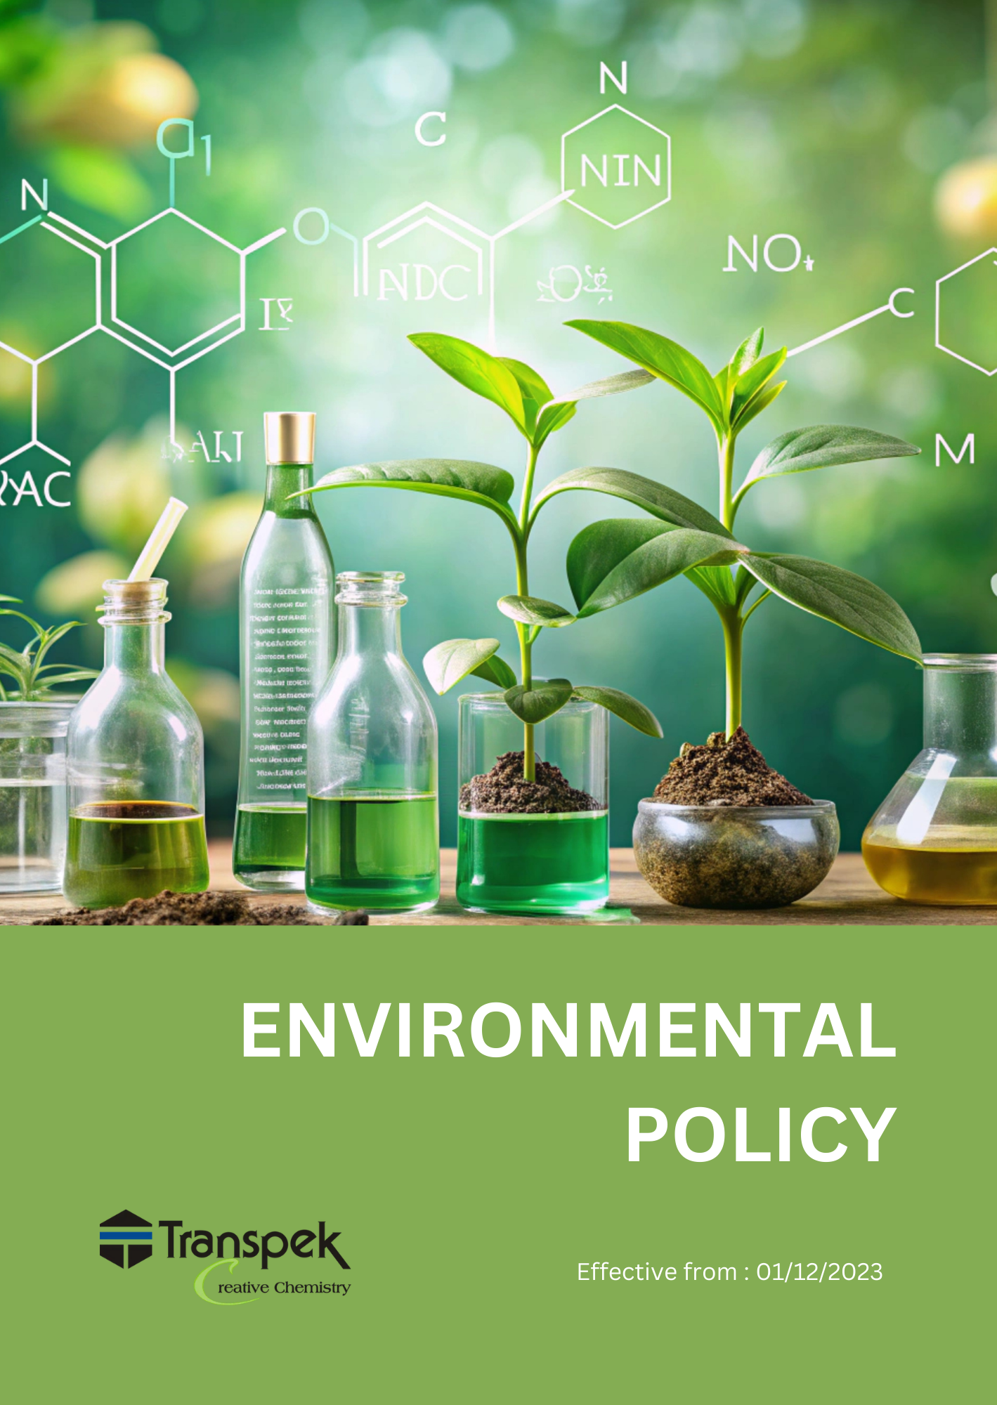

INDEX

INTRODUCTION 3
SCOPE 3
POLICY STATEMENT 3
KEY FOCUS AREA 3
QUALITATIVE TARGETS 5
QUANTITATIVE TARGETS 7
RESPONSIBILITIES 8
REPORTING 9
COVERED SDGS 9
REVIEW MECHANISM 10
REVISION HISTORY 10
EMPLOYEE ACKNOWLEDGMENT FORM: ENVIRONMENTAL POLICY 11

INTRODUCTION
Transpek Industry Limited, a key player in the chemical manufacturing industry, acknowledges its environmental responsibility. We are committed to implementing sustainable practices, ensuring compliance with environmental regulations, and reducing our ecological footprint. Our customer base span across various sectors such as pharmaceuticals, agrochemicals, and polymers, strive to integrate sustainability in every aspect, from production to distribution.

SCOPE
This Environmental Policy applies to all Transpek sites, including all employees, contractors, and other stakeholders involved in the company's operations.
 | Transpek Industry Limited
 | 4th Floor, Lilleria 1038 Gotri-Sevasi Road 390021 Vadodara, Gujarat India
 | At & Post: Ekalbara, Taluka: Padra, Dist.: Vadodara, 391440 Gujarat India
 | https://transpek.com/

POLICY STATEMENT
Transpek Industry Limited is dedicated to prioritizing environmental protection through pollution prevention, energy efficiency, and sustainable chemical manufacturing practices. Our commitment focuses on minimizing environmental impact and contributing positively to global ecological health.

KEY FOCUS AREA
Energy Consumption & Greenhouse Gases:
- Energy Efficiency: Implement energy-efficient systems to reduce consumption across production facilities, aiming to decrease greenhouse gas (GHG) emissions.

- Renewable Energy: Invest in renewable energy sources, such as solar installations, to replace fossil-fuel dependency and lower carbon emissions.

- Greenhouse Gas Emissions: Establish tracking, reduction, and reporting mechanisms for Scope 1, 2, and 3 emissions to minimize total GHG footprint across all operations.
Water Conservation & Pollution Prevention:
- Water Conservation: We implement water-saving techniques to reduce consumption throughout our chemical production and distribution processes. The thrust is on waste water recycling.
- Pollution Control: Rigorous pollution prevention measures ensure that chemical spills and leakages are minimized, protecting surrounding water bodies and ecosystems.

Air Pollution & Emissions Control:
- Emission Reduction: Our aim is to minimize air pollutants through optimized routes, transportation methods, and energy-efficient processes that lower SOx and NOx emissions.
- Pollution Control Technology: We invest in air pollution control technologies to mitigate hazardous air emissions from our manufacturing processes.
Materials & Waste Management:
- Waste Minimization: We are committed to reducing waste generation at source and promoting recycling initiatives in our chemical handling and storage processes.
- Hazardous Waste Compliance: Ensuring compliance with regulations for the safe handling and disposal of hazardous chemicals is a top priority.
Biodiversity & Ecosystem Protection:
- Wildlife & Ecosystem Protection: We have protocols in place to prevent chemical spills and safeguard biodiversity around our facilities.
- Protected Areas: Our operations ensure no encroachment upon ecologically sensitive areas, aligning our practices with biodiversity conservation goals.
Customer Health & Safety:
- Safe Chemical Handling: We implement stringent protocols to ensure the safe handling of chemicals, protecting both our customers and the environment.
- Sustainable Product Stewardship: We promote responsible chemical use, providing clear product labelling and guidance on handling, storage, and disposal.
Sustainable Consumption & Resource Optimization:
- Resource Efficiency: We are committed to optimizing resource use across our operations, ensuring minimal environmental impact through efficient use of energy, water, and raw materials.
- Sustainable Supply Chain: Our focus is on working with suppliers that follow sustainable practices, ensuring responsible sourcing and reducing the environmental footprint across our supply chain.
- Circular Economy Approach: We are actively adopting a circular economy model, focusing on reducing resource consumption, reusing materials, and recycling to promote sustainability throughout the product lifecycle.
Environmental Impacts from Use of Products:
- Product Longevity and Durability: Focus on increase supplying products in reusable and high durability containers like ISO tanks instead of single use packaging drums to reduce environmental impact
Environmental Impacts from Products End-of-Life:
- End-of-Life Recycling: Develop programs for safe disposal and recycling to limit product disposal impacts.

- Safe Disposal Programs: Establish customer support for unused products, enabling customers to safely return them for proper disposal or re-distil.
Environmental Services and Advocacy:
- Collaboration with Stakeholders: Partner with customers and suppliers to co-develop environmentally friendly solutions for mutual benefit.

- Eco-Labels: Introduce a certification program to recognize and promote customers adopting sustainable practices, enhancing their brand value.

QUALITATIVE TARGETS
Energy Consumption & Greenhouse Gases:
- Energy Reduction: Transpek is committed to reducing energy consumption across its facilities by implementing high-efficiency lighting systems, such as LED lighting, and investing in renewable technologies, including solar panels. These efforts support a transition to a low-carbon energy footprint, aligning our operations with sustainable practices.

- Greenhouse Gas Emissions: Track and reduce Scope 1 (direct), Scope 2 (indirect), and Scope 3 (value chain) emissions to reduce Transpek overall carbon footprint.

Water Stewardship:
- Water Conservation: We aim to reduce overall water consumption from ground water resource by using sewage water of surrounding village after treatment though biofilter & ultra filtration in cooling towers.
- Effluent Treatment: Our wastewater treatment protocols include implementation of Biofilter technology, which is patented and indigenously developed to ensure the highest standards of water quality.
- Greywater Recycling: Implement greywater recycling systems to reuse water from non-potable sources through our wastewater treatment protocols include implementation of Biofilter technology, which is patented and indigenously developed to ensure the highest standards of water quality.
Air Quality Improvement:
- Emissions Reduction: We already have electrostatic precipitators (ESPs) in Boilers & have closed loop chemistry to reduce air pollutants.
- Odor and Noise Control: We have measures in place such as activated carbon filters for Odor control and acoustic enclosures to minimize noise pollution from our operations.
Materials & Waste Management:
- Waste Minimization: Our goal is to reduce waste through recycling programs, composting systems, and the use of sustainable, biodegradable packaging materials.
- Hazardous Materials: We strictly adhere to regulatory compliance regarding the handling and disposal of hazardous chemicals, employing secondary containment systems and automated monitoring for chemical storage.
Biodiversity & Ecosystem Conservation:
- Sustainable Sourcing: We prioritize sourcing chemicals from suppliers that adopt green chemistry principles and sustainable land management practices to support biodiversity.
Customer Health & Safety:
- Product Safety Assurance: We ensure that all chemicals supplied meet rigorous safety standards using efficient quality control systems and real-time product tracking technologies.
- Emergency Response Protocols: We have established protocols for swift incident response using chemical spill containment kits and remote monitoring systems to detect and manage spills or accidents.
Sustainable Consumption & Resource Optimization:
- Resource Efficiency: We aim to optimize resource use by employing lean manufacturing practices, reducing material waste, and implementing resource efficiency management systems.
Environmental Impacts from Use of Products:
- Durable Packaging: Strive to increase chemical products supply with enhanced durability, reducing the need for frequent replacements and minimizing resource consumption over time. Ensure that containers and equipment, are made from corrosion-resistant materials, improving their longevity.
Environmental Impacts from Products End-of-Life:
- End-of-Life Recycling: Facilitate recycling and safe disposal methods to minimize waste and pollution associated with product disposal.
- Safe Disposal Programs: We have established a system to collect and safely dispose of unused customer products, ensuring environmentally responsible practices.
Environmental Services and Advocacy:
- Environmental Diagnostics: Provide services that help customers assess and mitigate their environmental impact.
- Sustainability Alternatives: Offer customers eco-friendly product alternatives, promoting practices that support global environmental health.

QUANTITATIVE TARGETS
Energy Consumption & Greenhouse Gases:
- Energy Reduction: To optimize processes / utilities & adopting energy-efficient systems in our chemical production to decrease energy consumption by 10% by FY 2029-30 from the baseline year FY 2022-23.
- Greenhouse Gas Emissions: Achieve a 15% reduction in combined Scope 1 & 3 emissions by FY 2029-30 from the baseline year FY 2022-23.
- Greenhouse Gas Emissions: Achieve a 50% reduction in combined Scope 2 emissions by FY 2029-30 from the baseline year FY 2022-23 by the solar panel Agreement.
Water Stewardship:
- Water Conservation: Reduce overall water consumption by 10% by FY 2029-30 compared to the baseline year FY 2022-23.
- Effluent Treatment: Ensure and maintain wastewater treatment meets the highest standards, achieving 100% water quality compliance every year.
- Greywater Recycling: Implement greywater recycling systems to reuse at least 15% of water from non-potable sources by FY 2029-30.
Air Quality Improvement:
- Emissions Reduction: Reduce air pollutants by implementing low-emission technologies to achieve a 15% reduction in emissions by FY 2029-30 from the baseline year FY 2022-23.
- Odor and Noise Control: Minimize unpleasant Odors and noise pollution, targeting a 10% reduction in reported incidents by FY 2029-30 compared to the baseline year FY 2022-23.
Materials & Waste Management:
- Waste Minimization: Achieve a 5% reduction in total waste generated by FY 2029-30 from the baseline year FY 2022-23 through enhanced recycling programs.
- Waste Disposal: Environment friendly method for disposal of hazardous waste, to achieve 25% of the total waste to be disposed for co-processing instead of incineration by FY 2029-30 from the baseline year FY 2022-23.
- Hazardous Materials: Maintain 100% compliance with regulatory standards for hazardous materials management and handling by FY 2029-30.
- Circular Economy Initiatives: Maintain closed-loop recycling systems to ensure at least 80% of SO2 generated as byproduct is recycled.
Biodiversity & Ecosystem Conservation:
- Reforestation Initiatives: Commit to maintain 25000 trees across the site.
Customer Health & Safety:
- Product Safety Assurance: Maintain 100% compliance with safety standards for all chemicals supplied.
Sustainable Consumption & Resource Optimization:
- Resource Efficiency: Improve overall Raw Material efficiency by 3% FY 2029-30 from the baseline year FY 2022-23.
Environmental Impacts from Use of Products:
- Increase Product supply in durable packaging: Aim to increase product supply in durable packaging by 10% by FY 2029-30 from the baseline year FY 2022-23 through the use of higher-quality, durable ISO tanks.
Environmental Impacts from Products End-of-Life:
- Safe Disposal Systems: Maintain the system of receiving and responsibly disposal of 100% of unused returned products from customers.
Environmental Services and Advocacy:
- Sustainability Alternatives: Increase the adoption of sustainability alternatives by 30% FY 2029-30 from the baseline year FY 2022-23 across all plants, aiming for a measurable reduction in environmental footprint.

RESPONSIBILITIES
Board of Directors:
- Oversees the overall environmental strategy and approves long-term sustainability goals.
- Ensures alignment of environmental initiatives with business objectives and stakeholder expectations.
Top Management:
- Committed to integrating environmental considerations into business strategies and allocating necessary resources for implementation.
- Monitors progress towards achieving set environmental targets and ensures accountability.
Environmental Managers:
- Oversee the implementation and maintenance of environmental practices across all facilities.
- Ensure compliance with relevant environmental regulations and standards through regular monitoring and assessments.
All Employees:
- Adhere to environmental procedures and practices outlined in the policy.
- Participate in training programs and contribute to the company’s sustainability initiatives.
Site Supervisors:
- Ensure that environmental protocols are followed during day-to-day operations.
- Report any non-compliance or environmental incidents to management promptly.
Health & Safety Teams:
- Monitor and enforce safety protocols regarding the handling of chemicals and waste management.
- Ensure compliance with safety regulations and protect employee health.
Human Resources:
- Implement ongoing training programs related to environmental awareness, sustainability practices, and safety protocols for all employees.
- Foster a culture of sustainability within the organization.

REPORTING
Environmental Performance Reports:
- Regularly compile and distribute environmental performance reports that summarize progress against established sustainability targets and goals.
- Reports will include key performance indicators (KPIs) related to energy consumption, water usage, waste generation, and emissions reductions.
Compliance Reporting:
- Ensure timely submission of compliance reports to regulatory authorities, detailing adherence to environmental regulations and any incidents that may have occurred.
- Maintain records of environmental audits, inspections, and assessments to demonstrate compliance with applicable laws and regulations.
Stakeholder Communication:
- Provide transparent updates to stakeholders, including employees, customers, and local communities, regarding environmental initiatives and progress.
- Utilize various communication channels, such as newsletters, social media, and the company website, to share achievements and address any environmental concerns raised by stakeholders.
Internal Reporting Mechanisms:
- Establish internal reporting channels for employees to report environmental concerns, incidents, or suggestions for improvement.
- Encourage a culture of accountability by ensuring that all reports are reviewed and addressed promptly.

COVERED SDGS
 | 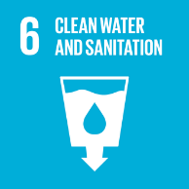 |  |  |  | 

REVIEW MECHANISM
The Environmental Manager oversees the implementation and review of this Environmental Policy. This policy will be reviewed every year to ensure its effectiveness and relevance to our sustainability objectives. Regular performance evaluations will be conducted biannually to assess progress against established targets, with findings documented and shared with the Board of Directors. Updates and changes will be communicated to all stakeholders as necessary, reflecting any operational, regulatory, or environmental challenges that may arise, ensuring continuous improvement in our sustainability practices.

REVISION HISTORY

Revision No. | Revision Date | Description of Change
00 | 01-01-2023 | Initial release of the Environmental Policy
01 | 01-04-2024 | Added the sections “Quantitative Targets” and “Qualitative Targets” and incorporated relevant SDGs
02 | 01-04-2025 | Revised sustainability targets with updated achievement timelines and added a formal Revision History table
03 | 01-04-2026 | Conducted the annual review of the Environmental Policy – No changes required

(Signature)
Approved By:
Designations:
Last Review Date: 01-04-2026 Next Review Date: 01-04-2027

EMPLOYEE ACKNOWLEDGMENT FORM: ENVIRONMENTAL POLICY
I, acknowledge that I have received, read, and understood Transpek Industry Ltd.'s Environmental Policy. I am aware of the company’s commitment to environmental sustainability, regulatory compliance, and responsible chemical manufacturing processes.
I understand my responsibility to uphold this policy, comply with environmental laws, and actively support sustainability initiatives in my daily work. I will report environmental concerns and contribute to continuous improvement efforts.
By signing below, I confirm my commitment to supporting Transpek’s environmental goals.

Employee Name: ______________________
Date: _______________
Employee Signature: ____________________

